Inserting an image into a page

If you want to insert an image into the content of a page, insert your cursor into the Content window where you would like the image to appear. Select the “Upload/Insert” icon directly above the Content window:

This will prompt you to either add a file from the “Media Library” (previously uploaded), or to upload a New image from your computer.
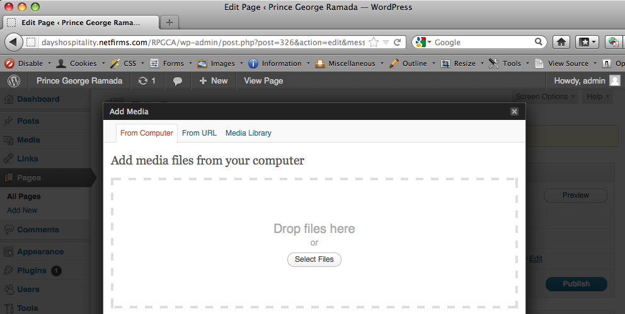
Choose the file you would like to upload or insert (below, for example). Once the file has been selected (or uploaded), the next window you will see is:
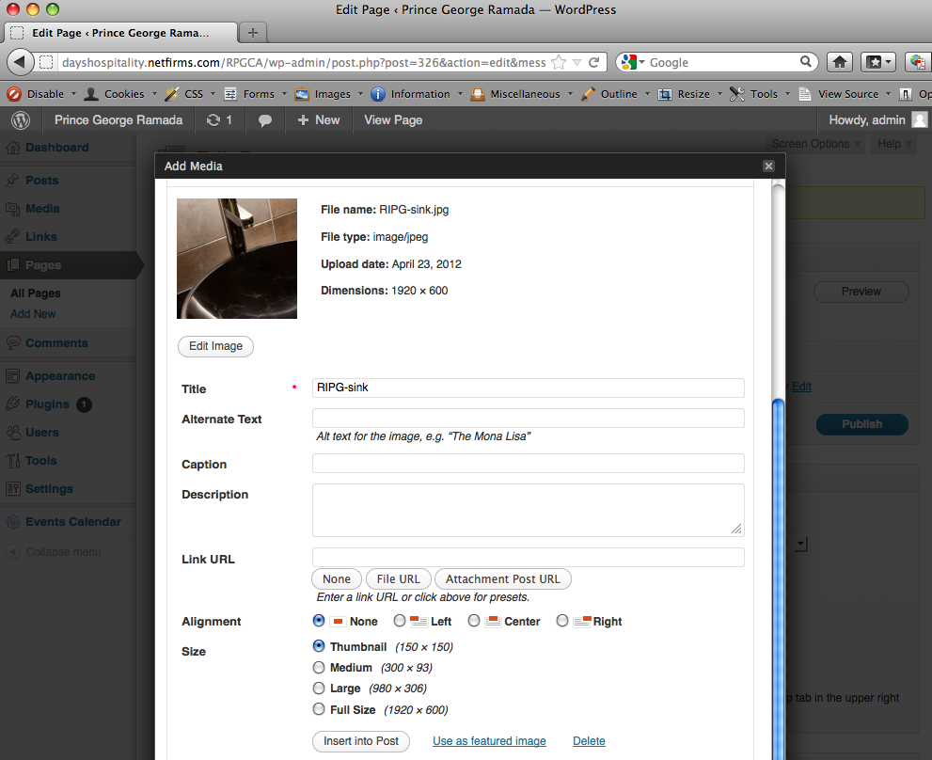
A preview of the image you’ve just uploaded will appear. You can fill in the Title, Alt text, Caption and Description. Default settings for this image are “Alignment: None” and “Size: Thumbnail (150x150)”. Beside “Link URL” you can have the thumbnail link to another web page (by typing in the URL); or choose from the buttons “None” (thumbnail has no link) or “File URL” (it will display a thumbnail image on your web page that opens the full size image when clicked).

Assuming you have already scaled and optimized your image using an image editing program such as Photoshop, and you want to display the image on your web page at full size, click the radio button to the left of “Full size” (and click the button “None” in the “Link URL” field. You can also choose the radio button for “Medium (300x93)” or “Large (980x306 — the same size image you see at the top of pages other than the home page)” or leave it as the 150x150 thumbnail.

When you click the “Insert into Post” button (directly below the image size options), the image will be inserted into your web page wherever your cursor was as you see here:
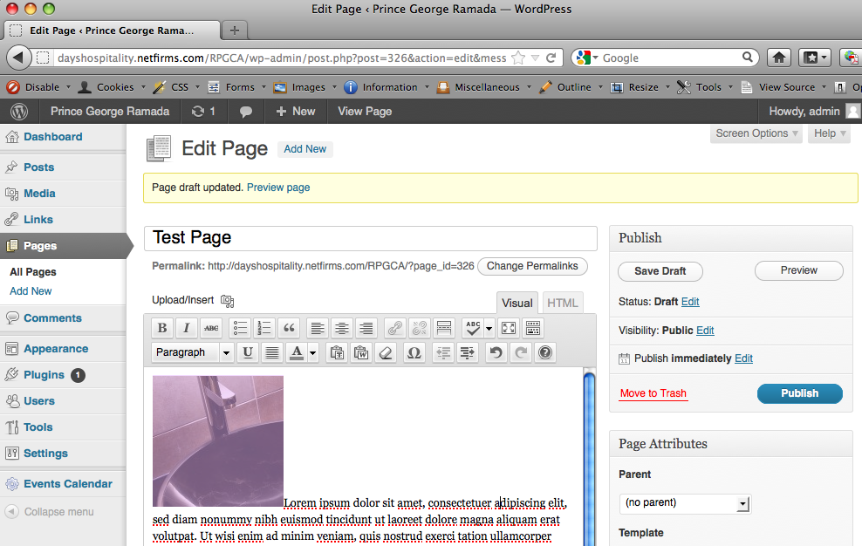
The alignment selection menu controls several formatting functions. For instance, the default “None” will display the bottom of the image inline with the first line of text. If we wanted the text to wrap around the image, you would click on the image and choose the “Edit image” icon that appears on top of the selected image thumbnail. It will open a pop-up window with tabs “Edit Image” or “Advanced Settings”. In “Edit image” select the “Left” radio button (which would display the image aligned left with a text wrap). Click on “Advanced Settings” as shown below:

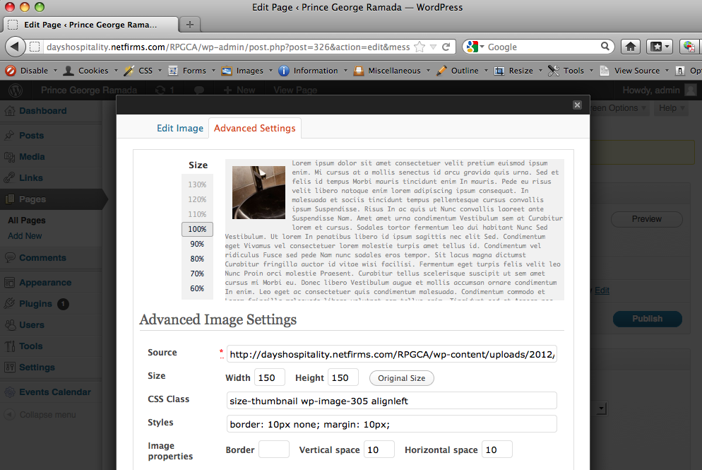
In this window, you can play with the size of the thumbnail (example 80%). The amount of padding between your image and the text is controlled by the values you enter in the Vertical space and Horizontal space fields beside “Image properties”. Let’s enter the value of 10 in each, which will give 10 pixels of padding on each edge of your image. Click “Update”, which closes the Insert/edit image window.

I’ve added Lorem Ipsum text to this test page to show how that will appear.

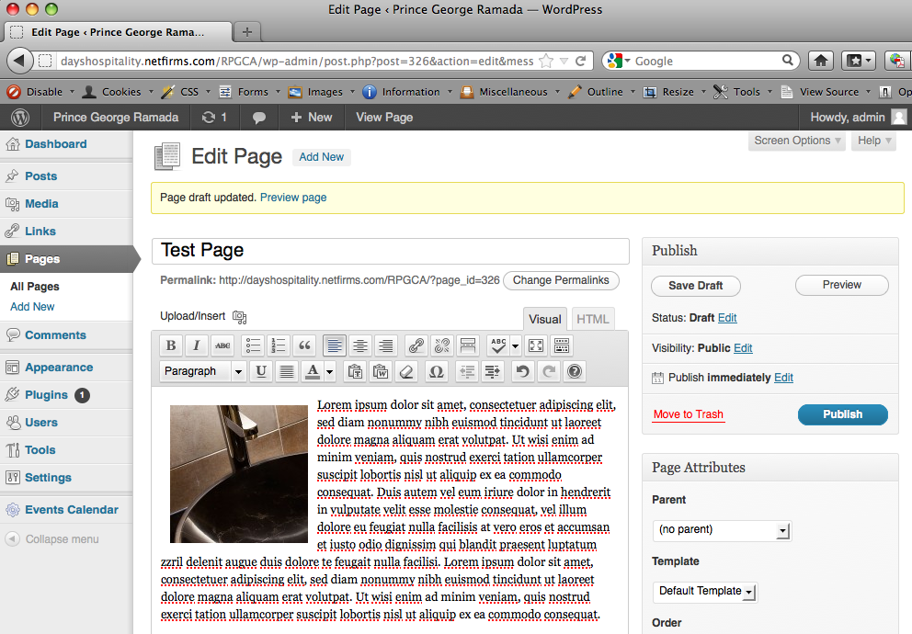

With a live page, you can open a second browser window and review the appearance of your page on-line. Experiment with the settings in the Upload/Insert image window to see how they control the appearance of the image on-line.

Inserting an Image Already on the Server

Your web server already has a selection of images that have been previously uploaded. To see them, click the “Upload/Insert” image icon, and rather than selecting a file to upload, click on the tab “Media Library” (3rd from the left). It will display all images that have been previously uploaded. If you want to insert an image into the content of your page, click on the link “Show” to the right of the image, which will open up details (as shown below). You can change Size: to Thumbnail and Link to: None etc. then click the “Insert into Post” button as you did previously. This will send that image to the page at the point your cursor is inserted.

Clicking the number links to the right, under the “Search Media” will display sequential sets of image thumbnails.

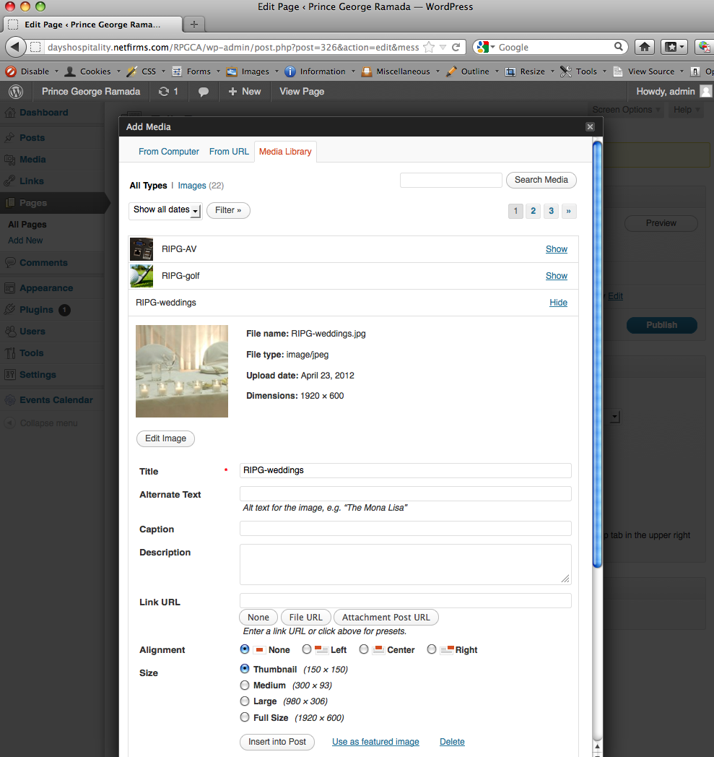
Any graphic format that is web-compatible (i.e. JPG, GIF, PNG) can be handled the same way.

